

**PROJECT DOCUMENTS**

**Project Title**

**WEATHER DATA**

**ANALYSIS**

**Team Number &Teammates:**

**TEAM 2**

**AASHIFA (01)**

**DHARSHAN R (08)**

**DIVYA (10)**

**Department: CSE-A**

**Year : II Year**

**Description About the project:**

The project "Weather Data Analysis" involves analyzing historical weather data for a specific location. The main objectives of the project include:

→**Data Collection:** Gathering historical weather data such as temperature, precipitation, and wind speed for a particular location from reliable sources.

→**Data Analysis**: Performing analysis on the collected weather data to identify trends, patterns, and relationships between different weather variables over time.

→**Visualization:** Visualizing the analyzed data using various charts and graphs to make it easier to interpret and understand the trends and patterns present in the weather data.

→ Weather data analysis finds applications across diverse sectors, including **agriculture, energy, transportation, disaster management, urban planning, insurance, and climate research**. By harnessing the power of data analytics and visualization, stakeholders can optimize resource allocation, mitigate weather-related risks, improve operational efficiency, and enhance resilience to extreme weather events. Ultimately, weather data analysis contributes to advancing scientific understanding.

**How DV works in real estate market analysis:**

Data visualization in weather data analysis serves as a critical tool for transforming complex and voluminous meteorological data into intuitive and insightful visual representations. Here's a breakdown of how data visualization works in weather data analysis:

1**. Data Exploration and Preprocessing:**- Before visualization, meteorological data undergoes exploration and preprocessing to **understand its structure, identify missing values, outliers, and inconsistencies, and prepare it for analysis**.This step involves tasks such as data cleaning, normalization, and feature engineering to ensure that the data is in a suitable format for visualization.

2. **Selection of Visualization Techniques:**- Based on the nature of the data and the analysis goals, appropriate visualization techniques are selected.Common visualization techniques in weather data analysis include **histograms, box plots, scatter plots, line charts, heatmaps, choropleth maps, and contour plots**.

3. **Exploring Data Distribution:**- Histograms, box plots, and kernel density plots are used to explore the distribution of weather variables such as **temperature, precipitation, and wind speed**.These visualizations help in understanding the typical range of values, identifying central tendencies, and detecting outliers or anomalies in the data.

4. **Temporal Analysis:**- **Line charts, time series plots, and calendar heatmaps** are employed to visualize how weather variables change over time.Temporal analysis helps in identifying seasonal patterns, long-term trends, and short-term fluctuations in meteorological phenomena.

5. **Spatial Analysis:**- **Heatmaps, choropleth maps, and contour plots** are utilized to visualize spatial variations in weather variables across different geographic regions.Spatial analysis facilitates the identification of regional climatic trends, microclimates, and weather anomalies.

6. **Correlation Analysis**:- **Scatter plots, correlation matrices, and network diagrams** are used to visualize relationships between different weather variables.Correlation analysis helps in understanding how changes in one variable may influence others and predicting future weather patterns.

7. **Comparative Analysis:**- **Bar charts, grouped bar charts, and stacked bar charts** are utilized to compare weather variables across different categories, such as **months, seasons, or geographic regions.Comparative analysis** enables the identification of differences, similarities, and trends within and across various subsets of the data.

8. **Interactive Visualizations:-** Interactive visualizations, such as **interactive maps or dashboards**, allow users to explore weather data dynamically, filter information based on specific criteria, and gain deeper insights through user interactions.

9. **Communication and Interpretation:-**The insights derived from data visualization are communicated to stakeholders, policymakers, and the general public through reports, presentations, and interactive visualizations.Effective communication and interpretation of visualized data help in **informing decision-making, raising awareness about weather-related risks, and fostering collaboration** in addressing meteorological challenges

**Code and Output:**

We can visualize the Weather data analysis using Data Visualization method to visualize the datas with different types of charts by the following points,

* Analyze historical weather data (e.g., temperature, precipitation, wind speed) for a specific location.
* Visualize trends in temperature or precipitation over time using line charts.
* Create heatmaps to show temperature variations across different regions.
* Boxplot of Temperature by Month.
* Barplot of Average Precipitation by Region.

● Pairplot for Correlation Analysis.

Packages that are used:

import pandas as pd import matplotlib.pyplot as plt import seaborn as sns

# Load the real estate dataset

data = pd.read_csv("C:\Dharshan\weather.csv")

# Display the first few rows of the dataset to understand its structure

print(data.head())

DATASET:

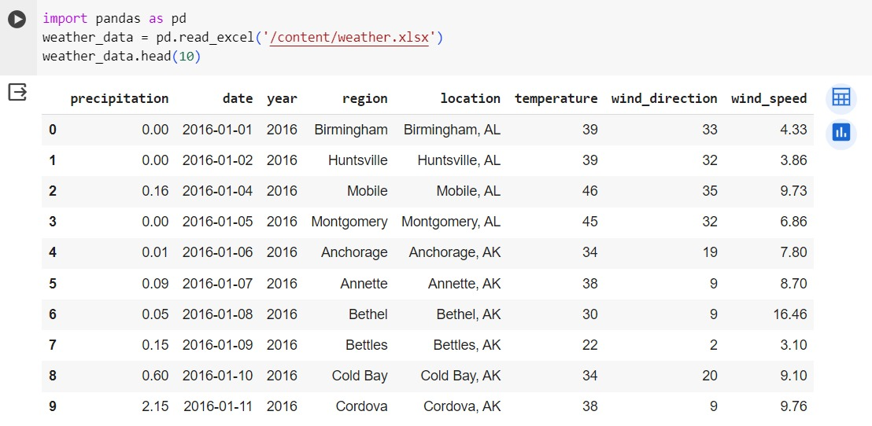

* Analyze historical weather data (e.g., temperature, precipitation, wind speed) for a specific location.

df = data.head(25)

#Analyze historical weather data (e.g., temperature, precipitation, wind speed) for a specific location.

plt.figure(figsize=(12,8))

sns.barplot(x='wind_speed',y='wind_speed',data=df,color='blue',label='region',orient='h')

sns.barplot(x='wind_direction',y='wind_speed',data=df,color='orange',label='reside',orient='h')

plt.title("Weather Analysis")

plt.xlabel("temperature")

plt.ylabel("wind speed")

plt.show()

OUTPUT: 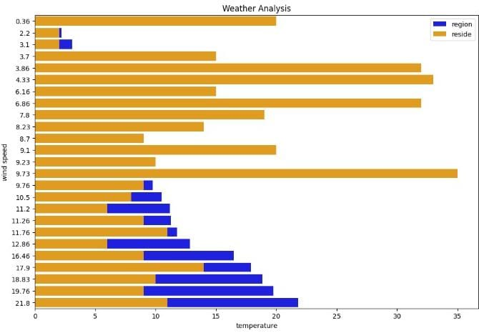

* Visualize trends in temperature or precipitation over time using line charts.

# Visualize trends in temperature or precipitation over time using line charts.

plt.figure(figsize=(10, 6))

sns.lineplot(x='wind_speed',y='wind_direction',data=df,label='wind speed', marker='o', linestyle='-', color='blue')

sns.lineplot(x='wind_speed', y='temperature', data=df, label='temperature', marker='o', linestyle='-', color='orange')

plt.title('General trend in weather')

plt.xlabel('humidity')plt.ylabel('precipitation')

plt.legend()plt.xticks(rotation=45)

plt.show()

OUTPUT: 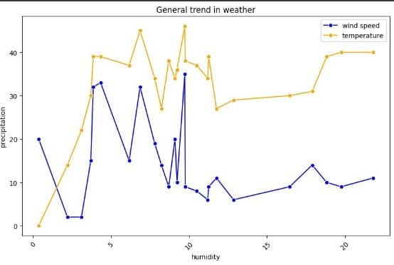

* Create heatmaps to show temperature variations across different regions.

# Create a heatmap to show temperature variations across different regions

Regioncode= input('Enter the region code : ')

reside = {

'Yr': [Regioncode] * 100,

'x': np.random.randint(0, 101, 100), # x-coordinates

'y': np.random.randint(0, 101, 100) # y-coordinates

}

df_service = pd.DataFrame(reside)

# Create a heatmap for average network distribution regarding their age

plt.figure(figsize=(10, 6))

sns.kdeplot(data=df_service, x='x', y='y', cmap='coolwarm', fill=True, thresh=0.05)

plt.title(Regioncode+' --- temperature analysis')

plt.xlabel('Temperature')

plt.ylabel('Range')

plt.show()

OUTPUT: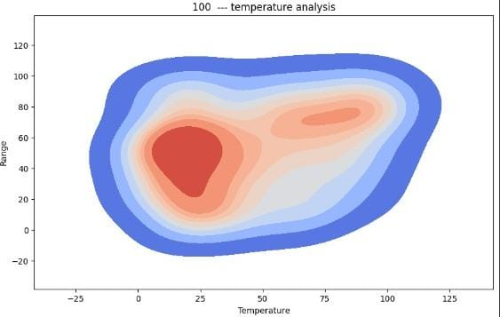

* Piechart for Analysis of wind speed

weather_data = pd.read_csv("C:\Dharshan\weather.csv")

subset_data = weather_data.head(8)

labels = subset_data['region']

values = subset_data['wind_speed']

plt.pie(values, labels=labels, autopct='%1.1f%%')

plt.title('Analyse of wind speed')

plt.show()

OUTPUT:

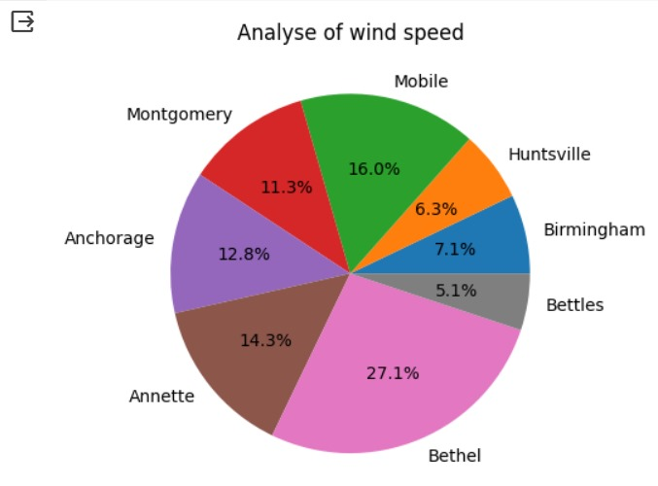

* Folium based on Temperature using descending order

# Sort the data based on temperature in descending order

sorted_data =weather_data.sort_values(by='temperature', ascending=False)

# Select the coldest place

coldest_place = sorted_data.head(1)

location = coldest_place['location'

# Create a map centered around the mean latitude and longitude of the data

map_weather = folium.Map(location=[62.0874, 152.7311], zoom_start=6, width=900, height=500)

folium.Marker([62.0874, 152.7311], popup=location).add_to(map_weather)

print(location)

map_weather

OUTPUT:

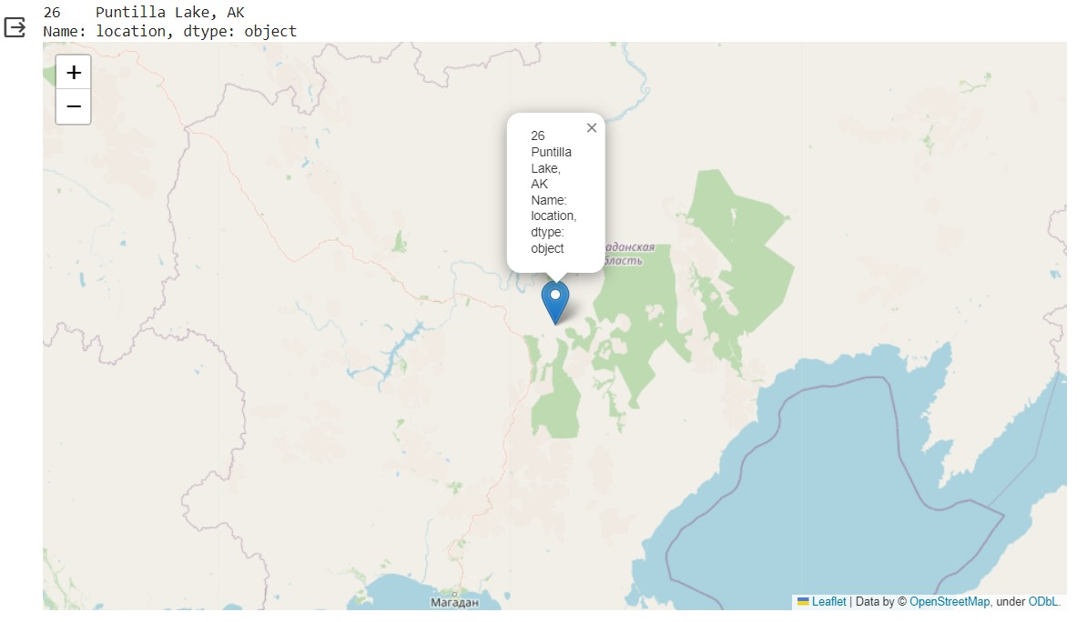

**Github Link:**

<https://github.com/Dharshanreddy003/Weather-data-analysis.git>

**THANK YOU!**